http://www.thejoyofshards.co.uk/tuscan/fountain.shtml

塔羅公園

Niki de Saint Phalle's Tarot Garden
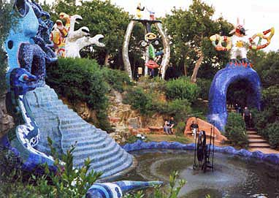 | A cascade flows over blue steps leading from the mouth of The High Priestess, and collects in a large pool. A moving metal sculpture (The Wheel of Fortune), designed by Niki's late husband and collaborative partner Jean Tinguely, sprays jets of water into the air. A stepped path leads up through the arch of The Sun towards the Hierophant (or Pope) and the serpents' heads of the "Tree of Life" (inside which is the Hanged Man). The next picture shows the High Priestess face on, the sight which greets you as you approach up a dusty slope from the entrance gate.
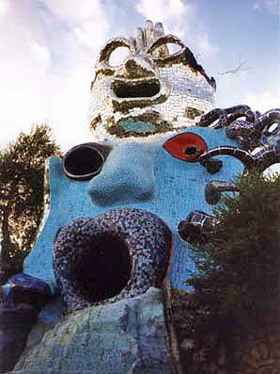 | The High Priestess, with The Magician above her, in mirror glass.  The "venerable ox-eyed" High Priestess is the embodiment of Juno, the feisty protectress of women. For Niki de Saint Phalle, she also represents the irrational unconscious with all its potential. The "Bird of Juno", the peacock, has wandered - we will meet it later.  The Magician is associated with qualities such as imagination, originality, creativity and determination to see a task through to completion even against great odds.  This card could be a fitting symbol for the achievement of the Garden itself, in the face of many considerable difficulties, but the artist connects this card with the divine creator of "the marvelous joke of our paradoxical world".
The Empress takes the form of a sphinx. Inside is a large living space, a womb of sparkling mirror glass. Her huge breasts provide nourishment and shelter - there is a kitchen in one and a bedroom in the other. She is a representation of feminine productivity, fruitfulness and fertility.  As with the rest of the Garden, this structure was built up from rods of welded iron and steel. A wire mesh was stretched over this armature, then sprayed with concrete. The surface of the concrete was finished by hand before the mosaic of tiles, mirrors and handmade ceramics was applied.  Running over The Empress' back is a roof terrace which looks out towards the Mediterranean. | 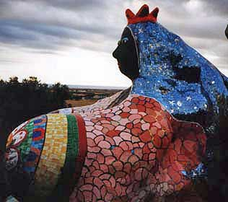
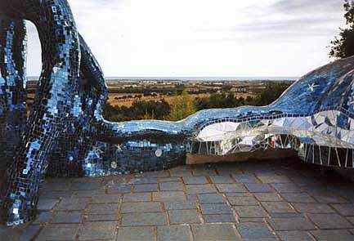 |  | The roof terrace. The walls are adorned with stars, planets and other celestial objects. We tried to imagine how it would be to visit by moonlight.....

The bathroom. This snake functions as the shower unit. | 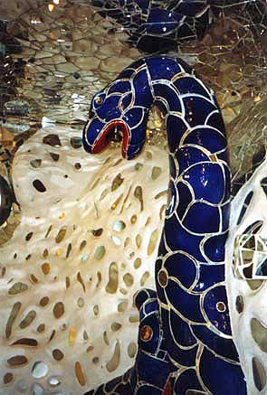

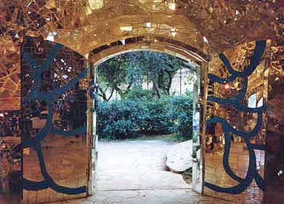 |  | The doorway of The Empress
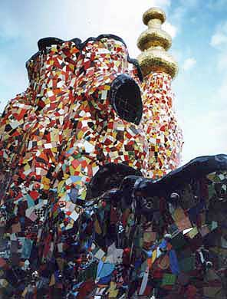  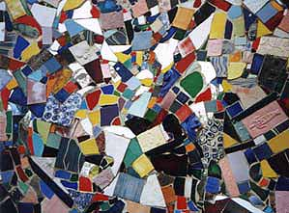  Perched on the ramparts is Juno's peacock. There are pictures of the inside of the courtyard on the next page. |  | The Emperor  In the tarot deck, the Emperor and Empress are presented in matching robes, both seated on their thrones, both with imperial regalia. In the Garden, however, they could hardly be more dissimilar. This symbol of masculine power, worldliness and the domination of the intellectual over the emotional, is centred around a courtyard. The walls are supported by columns, each with their own individualised decoration. You can climb stairs to walk the circuit of the walls, past the various structures which emerge from them. Organic towers arch over the walkway, mosaicked in reds and yellows and gold. Among them is a rocket ship, ready to launch on a scientific mission - or is it a missile, poised to destroy?  It's not hard to see the influence of Gaudì's sculptural architecture and Jujol's freeform mosaic trencadis (Niki de Saint Phalle visited Barcelona in 1955 and was awe-struck). As I looked around I couldn't help thinking that if I had made just one square metre of this I'd feel pleased with myself for a long time, yet here were acres and acres to be admired. Likewise I marveled at the precision of the tessellation and soaked up the enjoyment of the colours. It was only later I really was able to think about the deeper images represented here.  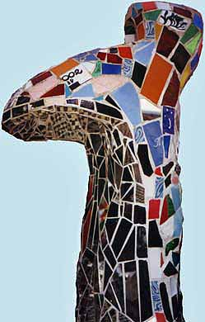
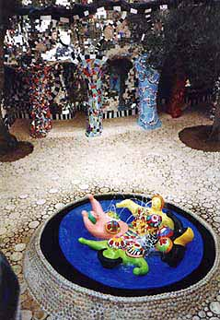 | The courtyard at the heart of The Emperor  Each of the columns has its own style, with purpose-made ceramics built in. The female figures in the fountain echo Niki de Saint Phalle's public scuptures, for example at the Pompidou Centre in Paris.  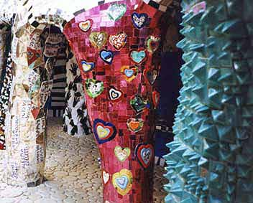

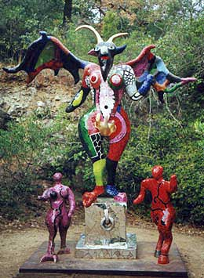  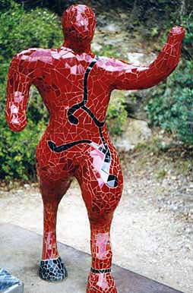 | The Devil  This is a particularly creepy and powerful statue. It's almost a caricature, but the vividness of the colour makes it unsettling. The Devil symbolises enslavement and "the loss of personal freedom through addictions of any kind". We all have them....  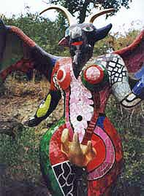  The detail is in The Devil: the underside of one of his wings.  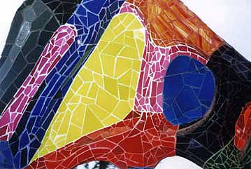

 | previous  (The Emperor-2) |  | back to list |  | next  (Death and Strength)
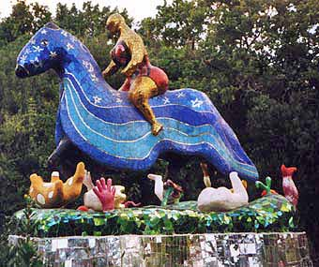 |  |  |  | Death  In contrast to the typical skeletal reaper, this image of death is a buxom woman, leveling all from horseback. Dismembered limbs and slain animals are scattered around her steed - this is a lady in a hurry.  For all the grimness, this memento mori is a symbol of renewal and regrowth. As Niki de Saint Phalle puts it "Without death, life would have no meaning". An awareness that "in the midst of life we are in death" is a liberation which helps us to recognise what is important and what is not.  And it's a fabulous piece of mosaic......

Strength  This dragon represents the glittering prize of inner strength and self-reliance that stems from confronting our own personal demons. What seemed terrifying before becomes a source of confidence and courage. | 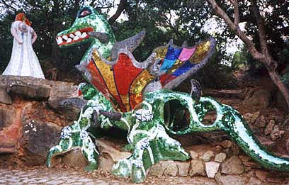

 | previous  (The Devil) |  |  | back to list | next
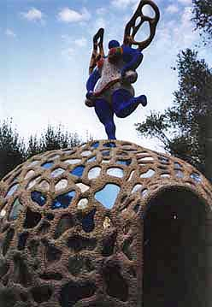 |  |  | Temperance  This was perhaps my favourite space in the Garden. Although enclosed in a dome (which reminded me of Victorian ice houses, or Suomi buildings in arctic Sweden), the thousands of mirror pieces inside made it appear much larger than on the outside. As people walked in, their reflections leapt to span the ceiling and danced around above them.  The theme of this tarot card is moderation and synergy. Compromise can feel like a constraint, but it can also bring the greater freedom which comes with reaching an understanding.  The angel of temperance stands on the top of the dome, and inside is a shrine with a black madonna. The photo at the lower right is of Jean Tinguely, who died in 1991.

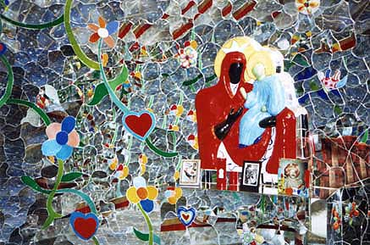
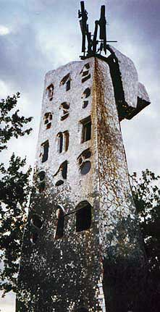 | The Tower  This is an ancient metaphor for the destruction of things thought to be safe and secure. As we gazed up at it on September 19th 2001, it seemed immensely, sadly, poignant.  The low evening sun was starting to catch the mosaics and they took on a new appearance again. There was so much to see here, to wonder at and to be inspired by. Too much to take in with a single visit.....

